Data transfer with Arduino and ESP8266 wireless module for stock control of vending machine

Tugay Goru, Engin Yürek, ITU

***Abstract. We design the IoT system for the stock control of vending machine. It uses the Arduino Uno and ESP8266 module. Although the connection is not always guaranteed with ESP8266, to compared with its contributors ESP8266 is cheaper and easier to use. The control is provided by sending e-mail to user, based on extended SMTP protocol which avoids the problems of regular SMTP. Furthermore, ESMTP is useful for sending e-mail via the system designed by Arduino and ESP8266.***

***Keywords—Arduino, ESP8266, SMTP, IOT, vending machine***

I. Introduction

Nowadays, it is no doubt that technology becomes widespread more than ever. This proliferation of technology significantly manifests itself in the internet. It is easily connected to internet via wireless system, ADSL or GSM. Due to spreading internet protocols, it increases interaction between objects and people, furthermore the objects have the own internet access. As a result of these developments, as described by the technology world the internet of things takes place in the technology. Over 5 years IOT has reached many different areas of usage and gained the desired popularity.

The Internet of Things (IOT) is a system of communication in order to transfer data over a network protocol between smart devices, animals or people without any interactions. It is allowed that the objects can be controlled by remote point. [1] According to Cisco, approximately 25 billion devices connected to the internet in 2015 and it is expected that its number reaches to 50 billion in 2025. Although the difficulty of the modulation to IPv6, the costs of meeting the energy needs of sensors that can reach millions are little obstacles to progress now, thanks to the contributions and efforts of the relevant institutions and the companies, it is expected that IOT will handle these problems. Thanks to IOT, the distribution of the world’s resources is practically improved.

The main goal of this paper is summarized like so; to increase satisfaction among customers with its own vending machine by making inventory control of vending machines, to systematize the supply of products by sending manager an e-mail that include the list of the almost finished products by using Arduino and Wi-Fi, to satisfy customers' needs continuously due to transmitted data to the manager.

The parts of the simulation of design are one Arduino UNO, one ESP8266 and one keypad compatible with Arduino.

*A. Arduino*

Arduino is an open source hardware and software platform which greatly simplifies development process with various easy to use hardware modules and IDE. Having many specialized versions of boards such as Arduino Uno, Arduino Pro, Arduino Pro Mini, Arduino Micro and Arduino Nano for entry level projects, Arduino Mega, Arduino Zero and Arduino Due for enhanced projects, Arduino Yun, Arduino mkr1000, Arduino Ethernet shield, Arduino GSM shield, and Arduino Wi-Fi shield for internet of things applications, Arduino Gemma and Lilypad Arduino main boards for wearable technology projects, make Arduino really popular among hobbyists, newbies, artist, designers, students, and anyone interested in electronics.

In addition to this variety of boards, to compare with others, Arduino also have advantages on other fields. It is cheaper than other boards which makes it usable for students and developers live in relatively poor districts. It has light weight and easy to use IDE and is able to run on different platforms like Windows, OSX and Linux operating systems while its most counterparts support only Windows. Its open source nature created a vast community and with the support of this community it meets the expectations for new trends and provides effortlessness troubleshooting. Furthermore, programming Arduino does not requires extra tool and it registers board to computer over a virtual serial port which makes serial communication extremely easy. Although Arduino has many types of board for supporting specific projects the most common board is Arduino UNO due to its general purpose structure.

[2]It consists ATmega328 microcontroller which has countless of features like timers, PWM pins, external and internal interrupts, multiple sleep modes, 2KB SRAM, 1KB EEPROM etc. Arduino also has 16mhz clock, 32KB flash memory, 12V external power supply port, 5V and 3.3V power pins, 6 analog I/O pin ,13 digital I/O pin, I2C support and special purpose LEDs.

*B. ESP8266*

ESP8266 is a low priced and small sized Wi-Fi module with integrated TCP/IP support that provides any microcontroller to access Wi-Fi network. In addition to this, ESP8266 has processor and storage capability to woks standalone. [3]It consists 32-bit RISC CPU, 64 KB of instruction RAM, 96KB data RAM and 512KB to 4MB external QSPI flash memory. All this features make ESP8266 module popular among the developers especially who works in IOT projects.

*C. Keypad*

Keypads is used to input data while a program is running. It is economical and practical solution to provide input and it is mounted easily whenever they are needed. There are 4X4, 3X3 or various configurations available in market. It includes letters, numbers and signs Thanks to Keypad.h. library, the keypads works properly with Arduino.

II.SMTP

Electronic mail (e-mail) is the most common way of modern-day communication. Although there are many protocols available, simple mail transport protocol (SMTP) is the most prevalent, practical and simple. The SMTP is a common, simple and text-based communication protocol that is utilized in order to send only electronic mail among multiple hosts [4]. E-mail protocols are developed for different operat4ing systems. There are gateway of these protocols to SMTP. SMTP enables communication between the Mail User Agent (MUA) and Mail Transfer Agent (MTA), which stores and forwards the mail. It runs on top of TCP layer and uses port 25 and 587 over TCP.

The client computer sends the required credentials to connect to an outgoing mail server without authentication. For the reason of non-authentications, SMTP is also used for spam mail

POP3 or IMAP protocol used to retrieve e-mail. The free e-mail servers such as G-Mail, Outlook support the SMTP.

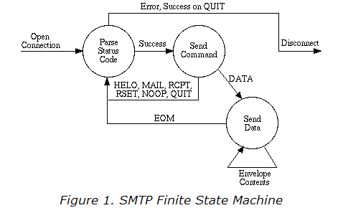

Several problems exist due to simplicity of SMTP. The length of message, timeout and infinite mail storms are the some of the ultimate problems. Therefore, Extended SMTP (RFC 2821) is recently used. The difference lies in sending an EHLO message instead of HELO at the beginning of communication. If it is not rejected, it allows new commands and parameters for sending e-mail. Otherwise the process is same as before.

III.ALGORITHM

We simulate a machine that have 5 type of products and stores 15 pieces for each product. If the number of remaining products becomes less than critical level, communication between the ESP8266 and email server will start. Since all mail servers accept data that encrypted with TLS we used an intermediary server which encrypts our data and sends it to desired destination.

* To start to communicate with intermediatery server, ESP8266 have to connect host over a suitable port. In our case host is mail.smtp2go.com and port is 2525.
* After successful connection we sent EHLO command with our IP which informs the server that client wants to communicate with extended SMTP protocol.
* In return server sends “*70:220 mail.smtp2go.com ESMTP Exim 4.86 Sun, 08 May 2016 18:39:03 +0000 OK SEND OK*”.
* Than we send AUTH LOGIN command with “*334 username*”.
* Server returns OK.
* In response to OK answers we send
  + username,
  + password,
  + MAIL FROM:< >,
  + RCPT TO:< >,
  + SUBJECT:”…”,
  + mail content,
  + QUIT.
* After all this we close the TCP connection.

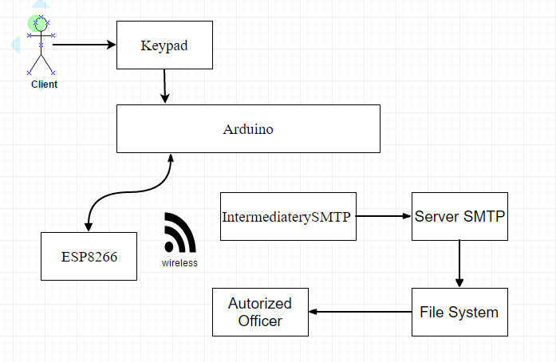

Figure 2. Functional Block Diagram

# CONCLUSIONS

In conclusion, Internet of things is more popular and it deeply affects our life more than ever. Stock control of vending machine is an example for IoT, which increases productivity of the vending machine and satisfies both users and supplier. On future days the project will be applied to the other storage machines like refrigerator or the place like larder etc.

REFERENCES

|  |  |
| --- | --- |
| [1] | D. Evans, «The Internet of Things:How the Next Evolution of the Internet,» Cisco Internet Business Solutions Group , 2011. |
| [2] | Atmel, ATMEL 8-BIT MICROCONTROLLER WITH 4/8/16/32KBYTES IN-SYSTEM PROGRAMMABLE FLASH DATASHEET, 2015. |
| [3] | Espressif Systems IOT Team, *ESP8266EX Datasheet,* 2015. |
| [4] | «http://www.smtp2go.com/,» SMTP2GO, [Çevrimiçi]. Available: http://www.smtp2go.com/articles/smtp-protocol. [Erişildi: 9 May 2016]. |